Scoliosis Facts
A normal spine is straight when viewed front or the back. Normally, when viewed from the side, the spine curves backwards in the chest area (kyphosis) and forward in the waist area (Lordosis). When viewed from the top down, all of the vertebrae should be facing forward. However, with scoliosis the spine curves to one side or the other in the thoracic and/or lumbar areas. From the top looking down through the center of the spine, some of the vertebrae are twisted which causes the ribs attached to the vertebrae to protrude, usually on the right side.
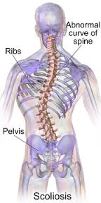

Scoliosis is a condition that may appear in more than one member of a family in the same or different generations. It does not develop as a result of anything that a child or her parents did or failed to do. Poor posture or carrying a heavy book bag does not cause scoliosis. Scoliosis is a spinal deformity that usually appears during adolescence, although it may appear in younger children as well.
How is it noticed?
One of the most common signs of scoliosis is a prominent shoulder blade, frequently the right one. One shoulder may also be higher and the child tends to "list" to one side. The hips may be uneven and one seems to be higher than the other. Scoliosis should not be confused with poor posture. Very often the first indication of scoliosis is that there is something wrong with the fitting of clothes. This is very apparent in girls when observing the hemline of a skirt or dress. When a child with scoliosis bends forward, the appearance of a rib prominence is one of the most striking signs.

Is scoliosis very common?
According to the Scoliosis Research Society, about l0%, of the adolescent population has some degree of scoliosis. This means that about 1,000,000 children just in the United States have scoliosis. About on fourth of these children, or 2%-3%, will require medical attention which may consist of observation for further progression of the curve, bracing or surgery, depending upon the degree of the curvature at the time of its detection. Some scoliosis may be so mild that treatment may never be necessary.
Mild scoliosis occurs nearly as often in boys as in girls. More serious curves are five to eight times greater in girls than in boys.
Studies conducted throughout the world show there is a very even occurrence of scoliosis. There is virtually no variation of racial or ethnic incidence.
Are there different types of scoliosis?
There are many causes for scoliosis. About 80%-85% of the patients have a type called IDIOPATHIC scoliosis. This means "no known cause". Idiopathic scoliosis often runs in families and appears to be due to genetic or hereditary factors. It is not known what "triggers" the development of the curve, or why some curves progress more than others. Scoliosis may occur in children who are otherwise perfectly healthy.
Also, scoliosis may be caused by NERVE and MUSCLE DISORDERS' such as cerebral palsy, muscular dystrophy and polio. Other known causes of scoliosis include: CONGENITAL which is caused by abnormalities in the formation of the vertebrae present at birth, CONNECTIVE TISSUE DISORDERS such as Marfan's Syndrome, and CHROMOSOMAL ABNORMALITIES, such as Down's Syndrome. Early diagnosis of the cause of scoliosis can aid in the proper treatment.
During adolescence scoliosis usually produces no pain and may be difficult to detect. Mild scoliosis may be present for several years before it is seen. One of the easiest ways to detect it is by using the forward bending examination. Most importantly, the physician should check the child's spine regularly until growth is complete since scoliosis may appear at any time during adolescence. The curvature may progress considerably during the last major growth spurt.
Can scoliosis be cured?
There are currently no medications to treat scoliosis, nor can its onset be prevented. When scoliosis is detected, the doctor may refer the patient to an orthopaedic spinal specialist for evaluation and treatment. This may consist of periodic examinations, including standing X-rays as needed to determine if the curve is increasing in size. If scoliosis is identified early, large curves may often be prevented by wearing a brace. Severe curves may require surgical treatment.

Adult Scoliosis
When scoliosis is mild in adults, the condition may remain unchanged or progress so slightly over the years that no serious problems may develop. However, in some people significant changes may occur. Curves may increase in size causing pain and interfering with function. In the most severe cases breathing also may be a problem. Osteoporosis (thinning of the bone) late in life can cause a mild curvature to increase significantly. Prevention of osteoporosis is especially important in people with scoliosis. Scoliosis in adults may be the result of a curve not treated during adolescence. Also, scoliosis may have developed later in life as a result of degeneration of the discs and joints of the spine.

Types of scoliosis curves

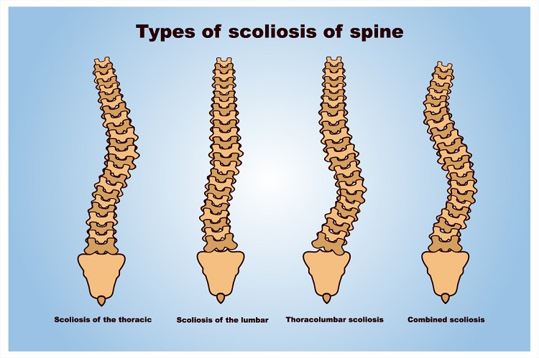

SIMPLE HOME TEST FOR THE EARLY DETECTION OF SCOLIOSIS

- Is one shoulder higher than the other?
- Is one scapula (shoulder blade) more prominent than the other?
- Does one hip seem higher or more prominent than the other?
- Is there a greater distance between the arm and the body on one side than on the other when the arms are hanging down loosely at the sides?
- Does the child have excessive "swayback" (lordosis)?
- Does the child have excessive "round shoulder" or "roundback" (Kyphosis)?
- Is there a larger "crease" at one side of the waist than the other side?
- Does the child seem to "list" or lean to one side?
- When you examine the child, have her bend forward with her arms hanging down loosely with the hands even and the palms touching each other at about the level of the knees.
- When in this position:
- ls there a prominence or hump in the rib area?
- ls there asymmetry in the hips or waist?

lf you have any "yes" answers or if the child has a brother, sister, parent or other close relative with scoliosis, consult your family doctor or orthopaedist.

