Khan Academy
Parent Instructions
- Go to https://www.khanacademy.org/math to create a Khan Academy account.
- Select “New User/Sign Up” then “Sign in to claim points”
- Sign in with gmail.
- In the search bar type in 7th grade math.
- Click on “7th Grade Math Khan Academy”.
- Start with “Negative numbers: addition and subtraction”. When you click on this icon, you will be taken to a page where there is a list of topics. Start with “Intro to adding negative numbers”. Watch the video and then do the practice exercises.
- When you successfully answer the questions in a topic, you will be taken to the next area. For instance, after “Intro to adding negative numbers”, you will go to “Intro to subtracting negative numbers”.
- Complete the required amount of subsections per topic. See table below for the required amount. You may complete any subsections per topic as long as the required amount it met.
- I would advise working on the course about 20-30 minutes/day.
- When you have completed all topics for math 7, please send the Percentage of Completion page to Mrs. Mendell at jmendell@aquinastars.org
- I have attached some copies of pages on the 7th Grade Math Course. These should serve as a guide to the flow of the course.
- The students who were in math 7 in 7th grade need to complete the required amount of 7th grade math Khan Academy course this summer
- Those that complete the minimum requirement will receive a 100% test grade upon return.
- Course Complete page should be emailed to me by August 23, 2018.
- Have a great summer
- See attached list of snipped navigation pages on the 7th Grade Math Course. These are only some examples. They do not constitute the entire course

7th Grade Khan Academy
Topic | Available | Subsections Required
Negative numbers: addition and subtraction | 41 | 20
Negative numbers: multiplication and division | 29 | 15
Fractions, decimals, & percentages | 28 | 14
Rates & proportional relationships | 36 | 18
Expressions, equations, & inequalities | 41 | 20
Geometry | 66 | 33
Statistics and probability | 26 | 13

Here is an example of what is under the category of “Negative numbers: addition and subtraction”
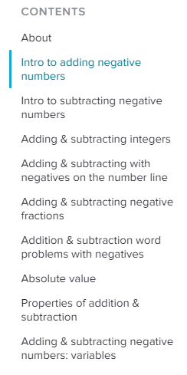
Once these are completed , move on to “Negative numbers: multiplication and division”

